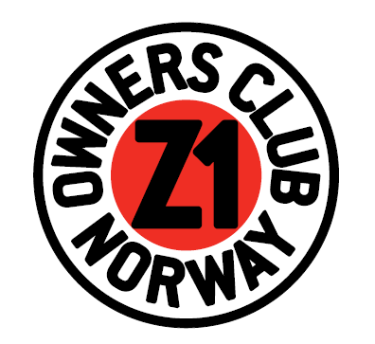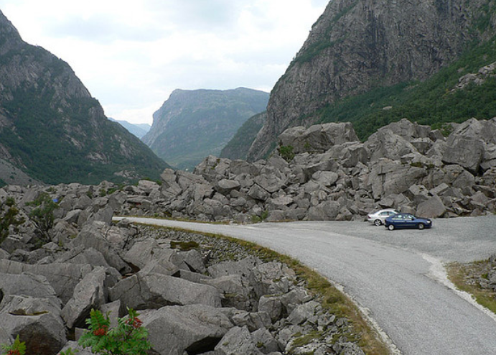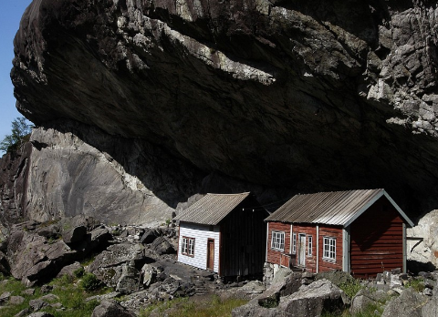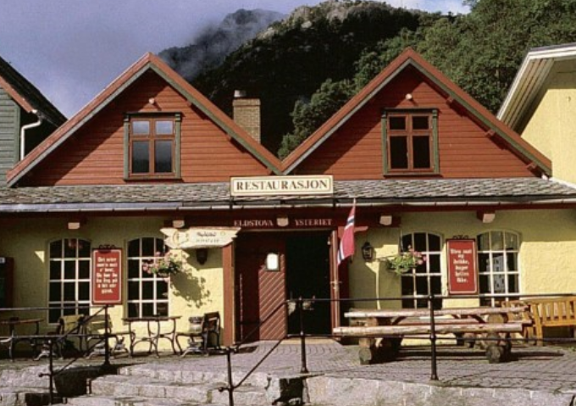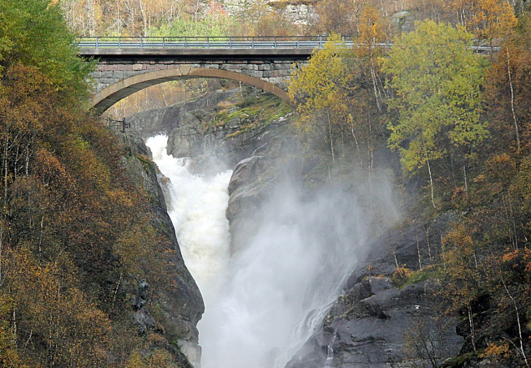
Welcome to the 25. International Z1 rally in Norway 2016!
- The anniversary rally is held in Lyngdal from 24 to 26 June 2016.
- 1 hour from the ferry port of Kristiansand if you come by ferry from Denmark!
- Nice rally site with food, drinks and good sanitary conditions.
- Live band on Friday!
- Ride out to “Norwegian South Cape” on Saturday.
- Prizes in several Z1 categories Saturday evening.
- GPS coordinates 58.185281,7.100902
- Z1OCN on Facebook: https://www.facebook.com/#!/Z1OwnersClubNorway
- For more info contact Morten: morten.rokbuvold@nordan.no
- We are planning a 2 day tour before the rally. This tour will start at the ferry dock in Kristiansand on Wednesday 22 June and end up at the rally on Friday afternoon. We will ride through some of the historical sites in the area on spectacular roads! (Jøssingfjord, Gloppedal, Tronåsen, Sirdal, Lyseboten, Valle….). More information will come in Z1 magazine and on Z1 Owners Club Norway’s Home and Facebook page if there is big enough interest.

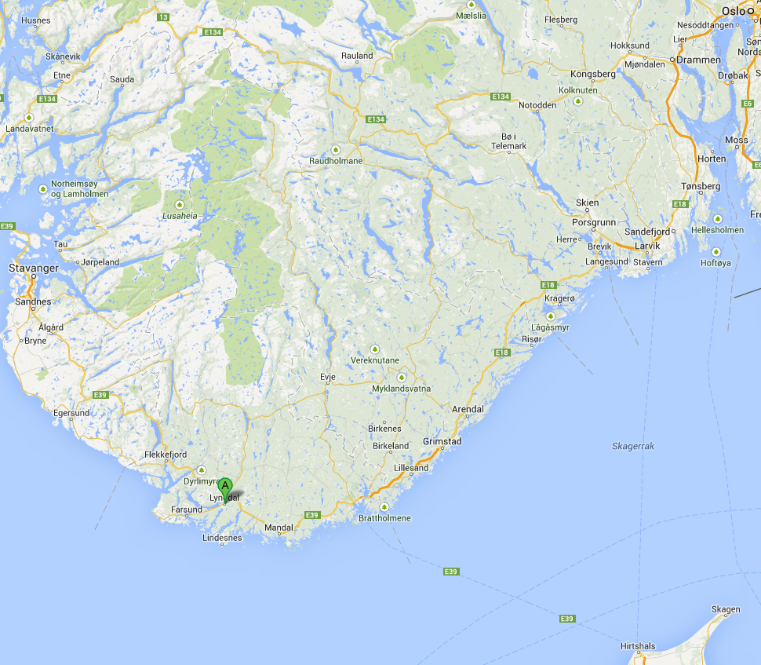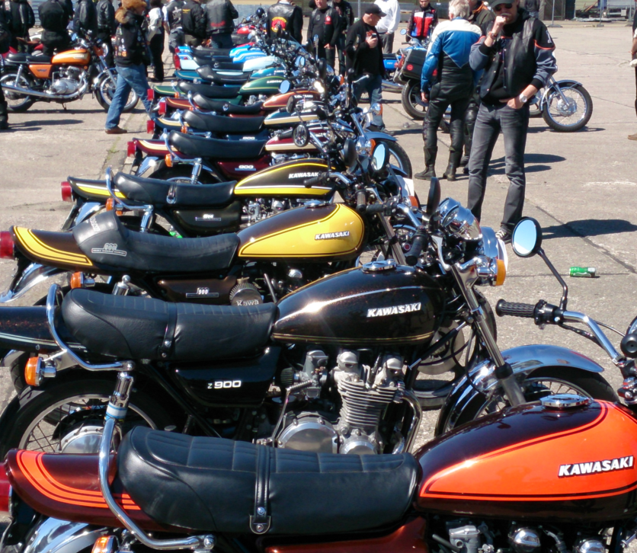

Welcome to Norway and Lyngdal!

